Michigan State University
DEPARTMENT OF CHEMICAL ENGINEERING AND MATERIALS SCIENCE

SIMPLE HAZARD ASSESSMENT

Experiment DESCRIPTION (single sentence explanation)

MATERIALS involved in the experiment (list using full chemical names)

- Full chemical name

- Circle all Global Harmonization System pictograms that apply

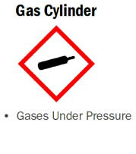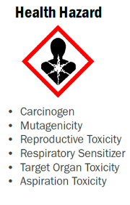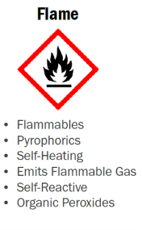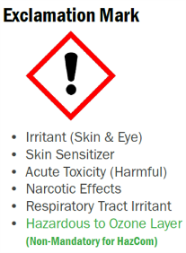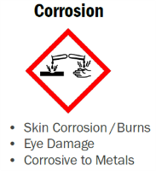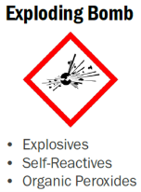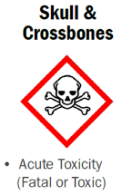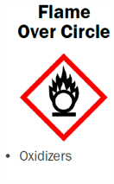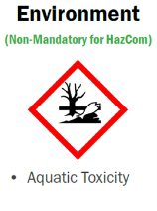

- NFPA rating

HAZARD | RATING | INSPECT MORE  CLOSELY IF | 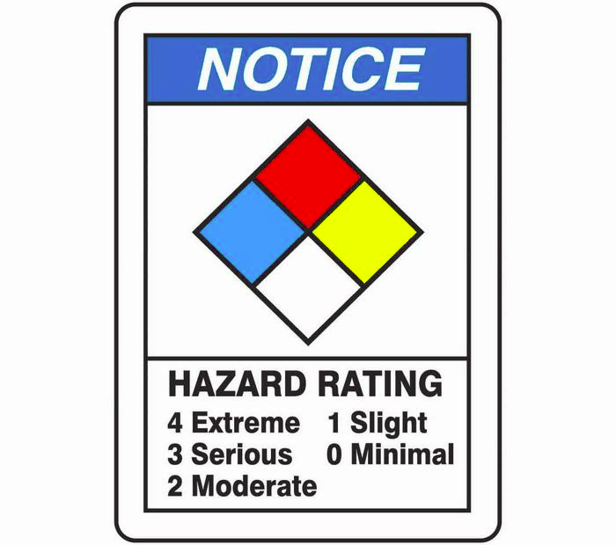
HEALTH |  | ≥ 3
FLAMMABILITY |  | ≥ 3
INSTABILITY |  | ≥ 2
SPECIAL |  | OX or W

- Known INCOMPATIBILITIES

Preparer’s Name (PRINT / SIGN) ________________________ Date ___________

PI Name (PRINT / SIGN) ______________________________ Date ___________

Is a more rigorous Hazard Assessment needed? No ___________ Yes ___________

